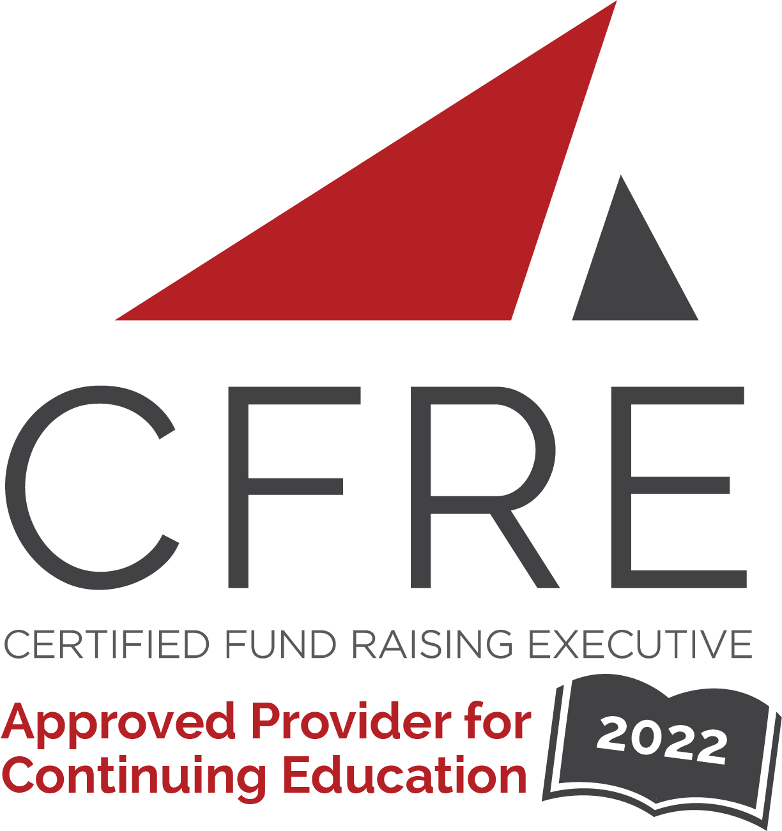  CFRE International has developed this form as a way for you to quickly track (and keep in your files!) the continuing education sessions you have attended. Simply check the boxes next to the sessions you attended. At the end of the conference, add up the total number of hours. Keep this sheet and you will be ready to complete your application form. All of the session slots listed are eligible for continuing education points on your CFRE application for initial certification and/or recertification. Sessions not listed here are not eligible for points. |  | CONTINUING EDUCATION POINTS TRACKER

Activity Organizer: - FIA
Title of Activity: - FIA Conference 2022
Names of Presenter(s): - Various
Dates and Location: - Chatswood, New South Wales, 6/2/22 – 6/4/22

Date: Thursday, June 2, 2022
Masterclass: 9:00 [am] – 3:00 [pm] (5 pts)
- [Launching A Digital-First Regular Giving Program To Smash Growth Targets]
- [Gifts In Wills – Developing A Plan For Accelerated Growth]
- [How To Create A 1 Page Digital Strategy]
- [Leadership Clinic – Develop Your Leadership Skills]
- [Apply The Mindset Of Donor-Centricity To Your Fundraising To Raise More Money For Your Mission]

Date: Thursday, June 2, 2022
Plenary: 4:30 [pm] – 5:30 [pm] (1 pt)
- [How Fundraisers Can Prepare for a Volatile Future]

Date: Friday, June 3, 2022
Session 1: 8:00 [am] – 9:00 [am] (1 pt)
- [Collaboration For Scale]
- [Hooked On A Feeling: Transforming Emotions Into Memorable Donor Experiences]
- [Building And Sustaining A Successful Major Gifts And Grants Strategy – The Key Success Factors]
- [Redkite And Coles | Australia's Most Successful Corporate Partnership]
- [Yellow Brick Road – The Why And How Of Direct Mail]
- [Ensuring Gifts In Wills Success – No Matter Your Size Or Budget]

Date: Friday, June 3, 2022
Session 2: 9:10 [am] – 10:10 [am] (1 pt)
- [What If Donors Trusted Us More – And Faster?]
- [Small Yet Mighty – How One Small Charity In Southern Tasmania Is Punching Above It’s Weight – The Hobart City Mission Story]
- [Applying Benchmarking Results For Improvement]
- [Lessons From Live Streaming: How To Maximise P2P Fundraising From Going Live]
- [Gifts In Wills Conversations: The Who, What, Why, Where And When]
- [How to get people to care]

Date: Friday, June 3, 2022
Session 3: 10:30 [am] – 11:30 [am] (1 pt)
- [Who Are The New Regular Givers? – Latest Research Suggests There Could Be A Completely New Engaged Audience We Are Ignoring]
- [The Checklist: The Must-Haves For A Successful Philanthropic Program]
- [How One Small Foundation Moved A Hospital – Giving Days]
- [Life After Death; The Impact Of Estates]
- [How I Accidentally Started A Charity In My Garage]
- [Rock Around The World – Uniting Charities In Event Fundraising, To Be Strong Together]

Date: Friday, June 3, 2022
Session 4: 11:40 [am] – 12:40 [pm] (1 pt)
- [Panel Discussion: Strengths Based Fundraising]
- [Unleashing The Power And Influence Of Culture]
- [Secrets Of Building Successful Fundraising Strategy In A Post Pandemic World]
- [Unlocking The Potential Of Digital And DRTV To Inspire Gifts In Wills]
- [Step Up With STEPtember: 11 Years On And Still Going Strong]
- [Accepting Gifts In Crypto Currency – Donors Without Borders]

Date: Friday, June 3, 2022
Plenary: 1:10 [pm] – 2:10 [pm] (1 pt)
- [Syd Herron Oration]

Date: Friday, June 3, 2022
Session 4: 3:30 [pm] – 4:30 [pm] (1 pt)
- [Using AI To Combat COVID With Heart Research Institute]
- [Telemarketing - Making The Right Call. A Deep Dive Into The Trends, Benchmarks, Drivers And Future Of Telemarketing In Australia]
- [Community Fundraising: Working Together To Achieve Great Things]
- [Boosting Bequests Online: Global Trends]
- [How NOT To: Mistakes, Face-Palms And Fundraising Fails]
- [Creating Mid Value From Nothing. How Plan International Australia Reimagined Existing Resources To Build A Mid-Value Program In 12 Months]

Date: Saturday, June 4, 2022
Session 1: 8:30 [am] – 9:15 [am] (1 pt)
- [Myth Smashers]

Date: Saturday, June 4, 2022
Session 2: 9:25 [am] – 10:25 [am] (1 pt)
- [Case Study On Lifeline’s 50% Growth In Regular Giving – Without Spending An Additional Cent]
- [Can Any Organisation Run A Multi-Million Dollar Fundraising Campaign? Best Practice Fundraising And Key Learnings From The Los Angeles LGBT Center Campaign And Other Local (Australian) Case Studies]
- [The Good, The Bad, The Great & The Ugly: How To Manage Agency Relationships]
- [How To Smash Your Targets With Facebook Fundraising And Build Lasting Supporter Relationships]
- [Tips & Tricks To Becoming A Boss Lady Of Fundraising]
- [No Half Measures In The HalfCut Challenge: A Story Of Passion And Purpose]

Date: Saturday, June 4, 2022
Session 3: 11:00 [am] – 12:00 [pm] (1 pt)
- [Walk Me Home / Ronald McDonald House]
- [The Global Muslim Heartbeat]
- [How To Build A Strong Mid-Value Case For Support. Creating Rich Story-Driven Experiences For Mid-Value Donors]
- [How To Supercharge Your Email Appeals]
- [Integration For Impact: How To Deliver Meaningful Campaigns From Ideation Through To Supporter Experience]

Date: Saturday, June 4, 2022
Session 4: 12:10 [pm] – 1:10 [pm] (1 pt)
- [The Start of a Beautiful Relationship – The science of acquiring donor love]
- [Taronga Conservation Society Australia Capital Campaign]
- [Courage Comes First: Understanding The Impact Of You]
- [GiveOUT Day- Growing The Pot Of Gold Under The Rainbow In Support Of The LGBTIQ+ Community]
- [How fostering collaboration and innovation grew Black Dog Institute's partnerships by 400% in one year]
- [Demystifying Data For Fundraisers]

Date: Saturday, June 4, 2022
Session 5: 2:30 [pm] – 3:30 [pm] (1 pt)
- [Panel Discussion – Future Gazing: What’s Next With Face-To-Face Fundraising]
- [Shitbox Rally: Humour, Adventure, Community And A Solid Partnership Bring Research With Rare Results!]
- [How To Retain Your Donors: A Best In Class Retention Showcase]
- [Leaders at all levels]
- [The Role Of NFPs In Impact Investing]
- [Mind the Gap]

Date: Saturday, June 4, 2022
Plenary: 4:00 [pm] – 4:45 [pm] (1 pt)
- [Stan Grant]

Total number of points attained: __________

